Alpha Kappa Alpha Sorority, Inc. ®
Psi Xi Omega Chapter
2020 Poetry Competition
Theme: A Salute to Maya Angelou

Maya Angelou, born April 4, 1928 in St. Louis, MO, is an African American author, poet, playwright, stage and screen performer, and director. She best known for “I Know Why the Caged Bird Sings” which depicts the story of her early life and discovery of her self-confidence, (1970) and “And Still I Rise” (1976). During a 4-year stay in
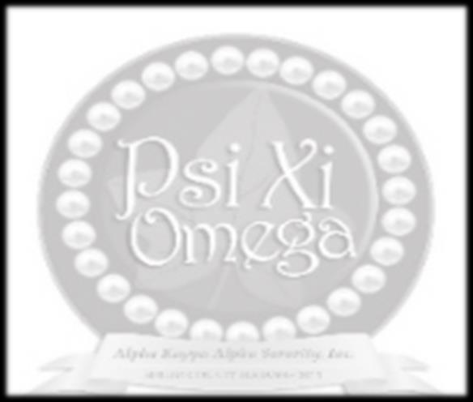
Ghana West Africa, she wrote “All God’s Children Need Traveling Shoes” (1986). In 2000, she was honored by President Clinton with the National Medal of Arts. Angelou’s work tends to carry themes of love, loss, struggle, and hope. Competition entries should convey similar themes.

Eligibility: Shelby County AL students in grades 9-12
Awards: 1st Place - $100.00 / 2nd Place - $50.00
Entry Deadline: November 13, 2020

NAME: _____________________________________________________________________________________

ADDRESS: __________________________________________________________________________________

EMAIL ADDRESS: ___________________________________________________________________________ (please do not use email address provided by school district)

HIGH SCHOOL / GRADE LEVEL: ______________________________________________________________

ENGLISH TEACHER NAME/EMAIL: ____________________________________________________________

PARENT NAME/CONTACT #: _________________________________________________________________

Competition Guidelines
- All entries must have an entry form. School enrollment may be verified.
- Each entry must be typed and have a minimum of 2 stanzas (8 lines per stanza).
- All work submitted must be the student’s own unpublished, original creation. Plagiarized work will be disqualified.
- Entries containing profanity, offensive language and/or inappropriate themes that suggest violence or explicit sex will be disqualified.
- Entries will be judged on originality, creativity, and the appropriate use of grammar and punctuation.
- Submissions will not be returned to the student.
- The decisions of the judges are final. Winners will be notified by December 1, 2020.
- All entries must be received by November 13, 2020. Email to psixiomega@gmail.com (include “Poetry Entry” on the subject line) or mail to:

Psi Xi Omega Chapter – Alpha Kappa Alpha Sorority, Inc.
Attn: The Arts Committee Chairman
P.O. Box 1602
Alabaster, AL 35007

