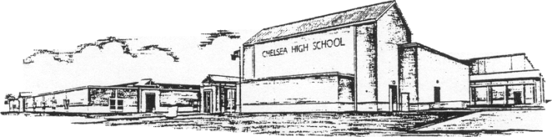

Chelsea High School
P.O. Box 639
K. Wayne Trucks Chelsea, Alabama 35043 Marisa Pinchin-Polk
Principal Telephone: 205.687.7200 Assistant Principal
Fax: 205.682.7205
LaTasha McMillan Ken Thornbrough
Assistant Principal Administrative Assistant

April 15, 2019
Dear Parents:
As we continue our health and safety education efforts at Chelsea High School, we will be conducting an anonymous student survey about school climate, including bullying, violence, alcohol, and drug use. The survey information will assist us in making informed decisions by providing us with the data we need to evaluate our safety/bullying and drug education programs.
To gather this information, we have chosen a Pride Surveys questionnaire. Pride Surveys has over 30 years of experience surveying students in school systems across the U.S. Survey procedures have been developed to protect your child’s privacy and allow for anonymous participation. While we encourage all students to participate, the decision to participate is voluntary. You may opt to send a refusal for your child’s participation. Alternately, your child will have the opportunity to refuse at the time of the survey. There will be no action against you or your child if your child does not participate.
If you prefer that your child not participate please inform our office, in writing, before Tuesday, April 16, as the survey will be administered Thursday, April 18. A copy of the survey is available in the principal’s office if you would like to review its content. A summary of the information gathered will be shared with parents when results are obtained.
We appreciate your working with us as we continue our efforts to guide our children towards safe and healthy behaviors.
Sincerely,

K. Wayne Trucks
Principal
Chelsea High School

