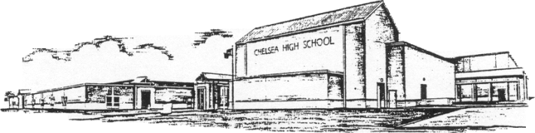

Chelsea High School

P.O. Box 639
K. Wayne Trucks Chelsea, Alabama 35043 Marisa Pinchin-Polk
Principal Telephone: 205.687.7200 Administrative Assistant
Fax: 205.682.7205
Cynthia Coyle Tyler Spruill
Assistant Principal Assistant Principal

Dear Parent/Guardian

Your child and their nutrition and education are a priority at Chelsea High School. In the spirit of what we are trying to do here- we want to help.

We want to make sure your child has the tools necessary to succeed in the classroom. The Alabama Childhood Food Solutions started a program called the Backpack Buddies.
Since food and nutrition are so closely linked with the ability to learn, we want to make sure students have nutritious meals over the weekend so they are ready to learn when they arrive at school on Monday.
For this reason, Backpack Buddies was created. This program provides participating students with a small bag of food each Friday afternoon that is discreetly placed in a backpack. There is NO COST to the participant’s family, for the food.

Please be aware that many Free and/or Reduced meal plans expire SEPTEMBER 22nd.

If you agree to allow us to help improve your student’s nutrition:
We will provide a bag, free of charge, which will need to be picked up by your child, from the back of the lunchroom in a designated area. The backpack will need to be picked up any time after lunch (on Friday), then returned (by Tuesday), so that it may be replenished for the following week. We are planning on beginning this service FRIDAY, SEPTEMBER 1st, 2017. The bags should be returned to the same location in the cafeteria.

If you do not want to participate in this program, please discard.

We want to assure you that we are doing everything possible to ensure that there will not be any attention or publicity resulting from this effort. Furthermore, your student, in no way will be singled out in front of his or her peers. We want to protect your child’s anonymity.

I do agree with this and would like “Backpack Buddies” support:
Please sign your name and your child’s name and return to Wayne Trucks:

Parent/Guardian : _______________________

Student name: _________________________

Sincerely,

