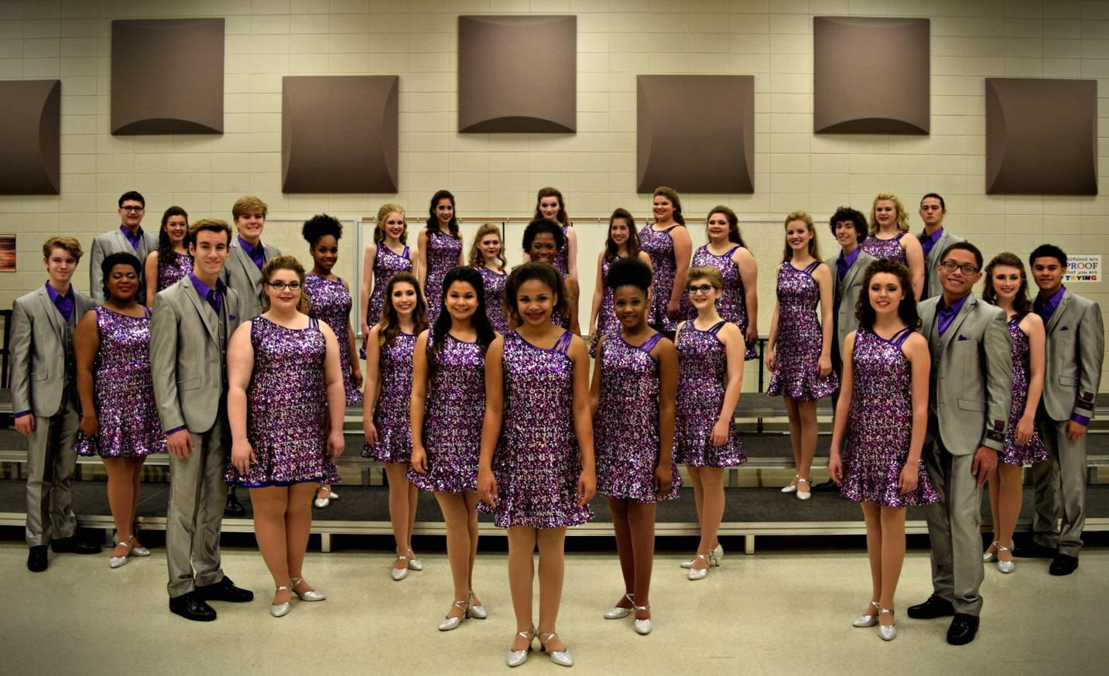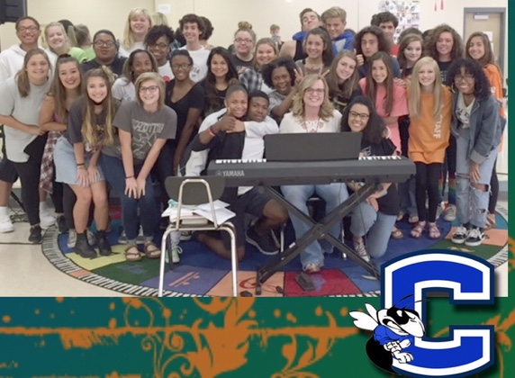

Come both days!

May 4 – Choreography –Wear comfy shoes for dancing!

May 5 – Bring your best audition song with karaoke accompaniment.

Award Winning

**Out of the Blue**

Show Choir Auditions

May 4 and 5, 2017

Chelsea High School Choir Room

INTRO PARENT MEETING TUESDAY,

May 2nd, 6 p.m.

CHHS Choir Room