**BATTLE OF SHELBY COUNTY SCHOOLS**

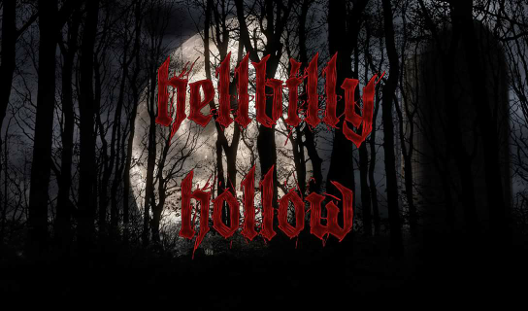

**What: Hellbilly Hollow - ghouly trail ride/scary corn maze/haunted house**

**When: Saturday October 8**

**Cost: $18 all 3 activities**

**Time: 7 PM until 11:30 PM**

**Why: School with most student support receives a % of the night's sales**

**How: Wear your school colors and support your school**

**Where: 425 Highway 467**

**Vincent, AL 35178**

**Students wear school colors and remember to tell ticket booth which school you represent.**

**205-365-6990**