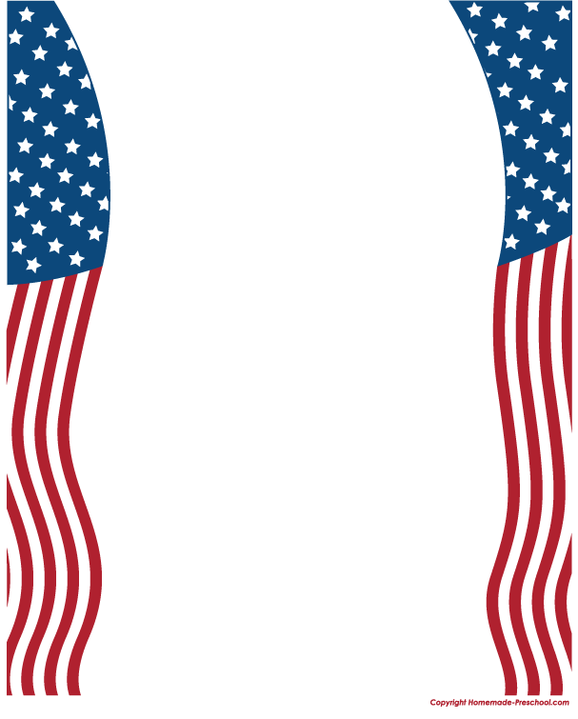

**Juniors!**

**Did you know**

**Shelby County was a county before Alabama was a state?**

**If you would like to learn more about your county, and serve as an ambassador for the**

**Shelby County Historical Society contact your Counselor or History Teacher for a**

***Shelby Sentinel* application packet today!**

* LEADERSHIP EXPERIENCE
* SCHOLARSHIP OPPORTUNITY
* COMMUNITY INVOLVEMENT
* HISTORIC PRESERVATION

The Shelby Sentinel Ambassador Program

**Application Deadline**

Wednesday, September 19, 2016

[www.shelbysentinel.com](http://www.shelbysentinel.com)